# SPSS merge 1 to many on key values

Begion situation:

* two datasets each containing key variables
* one dataset (a ‘lookup’ table/master table) contains **one** record per combination of key variables
* one dataset (slave table) contains per key variables **multiple** records

End situation

* one dataset (‘merged’ dataset) that contains per combination of key variables the multiple records of the slave table, but also the record of the look-up table repeatedly copied over those records

Example:

* key variables are ‘subject’. The look-up table contains the baseline characteristics of the subject (gender, age, etc), so one record per subject. The slave table contains the values of the subject over repeated measurements of the same outcome (satisfaction) over multiple occasions. Each measurement is a record for the subject, so multiple records per subject. The one-to-many merged dataset is the dataset containing the repeated measurement of subject in separate record, but the same baseline characteristics are repeated for a subject.

Lookup table

|  |  |  |
| --- | --- | --- |
| Subject | Gender | Age |
| 1 | M | 28 |
| 2 | F | 15 |

Slave table

|  |  |  |
| --- | --- | --- |
| Subject | Time | Outcome |
| 1 | 1 | 0.5 |
| 1 | 2 | 0.7 |
| 2 | 1 | 0.3 |
| 2 | 3 | 0.8 |
| 2 | 4 | 0.3 |

Merged:

|  |  |  |  |  |
| --- | --- | --- | --- | --- |
| Subject | Gender | age | Time | Outcome |
| 1 | M | 28 | 1 | 0.5 |
| 1 | M | 28 | 2 | 0.7 |
| 2 | F | 15 | 1 | 0.3 |
| 2 | F | 15 | 3 | 0.8 |
| 2 | F | 15 | 4 | 0.3 |

## SPSS elaboration (two key variables)

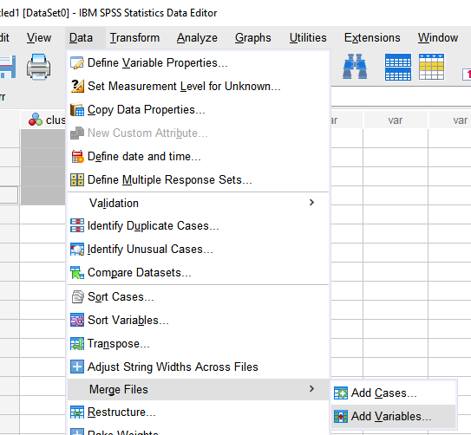

Activate the lookup table and select the slave table

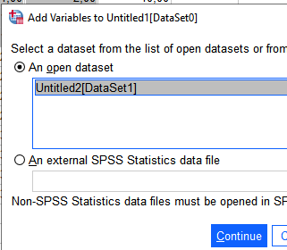

Choose the merge method

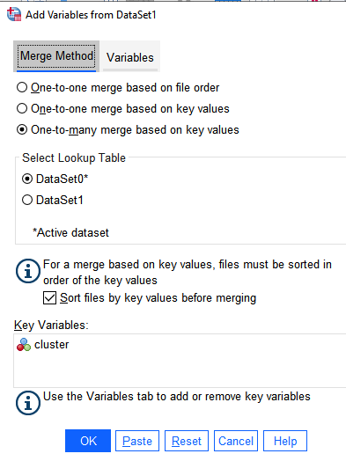

If needed add/change key variables by the ‘variables’ tab

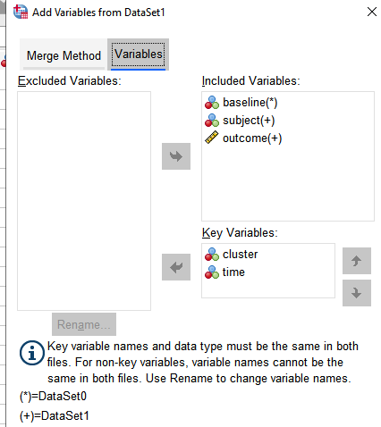

This results in the following code you can run

DATASET ACTIVATE DataSet0.

SORT CASES BY cluster time.

DATASET ACTIVATE DataSet1.

SORT CASES BY cluster time.

DATASET ACTIVATE DataSet0.

MATCH FILES /TABLE=*

/FILE='DataSet1'

/BY cluster time.

EXECUTE.

Note that the look-up table is replaced by the merged file, so

**be sure to save it before**

**and save the merged file under a different dataset name**